**Lab 11: Using DistCp**

Use the HDFS Shell *-put* command to upload the any file from /usr/share/licenses directory to the HDFS /user/root directory. Example below, however any text file will do. Then verify that the file has been uploaded.

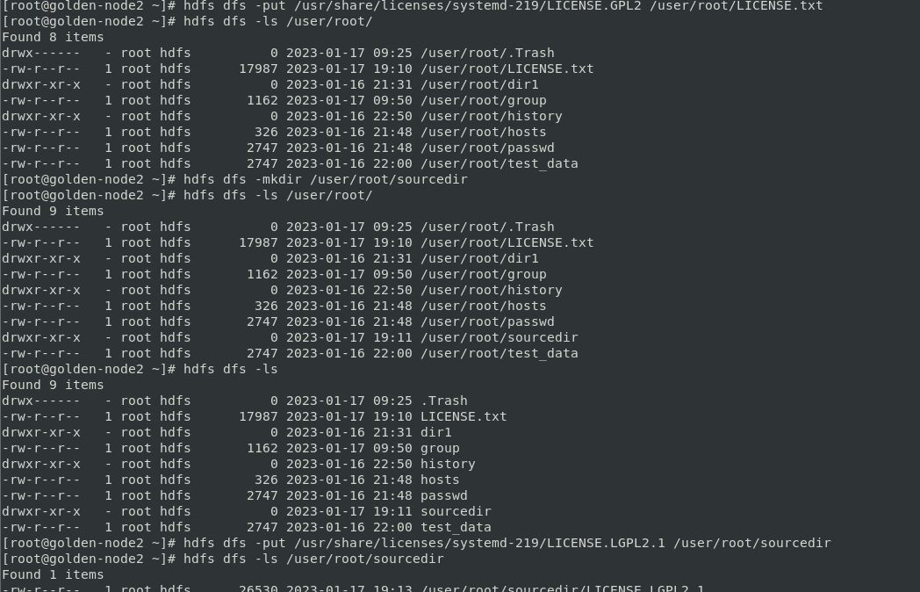

Use the HDFS Shell *-mkdir* command to create an HDFS target directory named /user/root/targetdir. Then verify that the directory was created

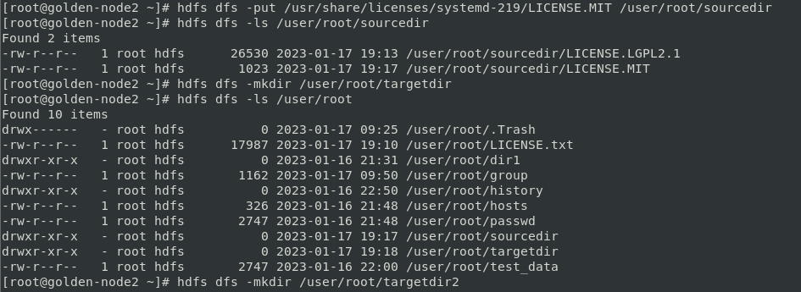

Copy the /user/root/LICENSE.txt file to the /user/root/targetdir directory using the *distcp* command. Then verify that the file was copied.





Distcp command



This lab is incomplete